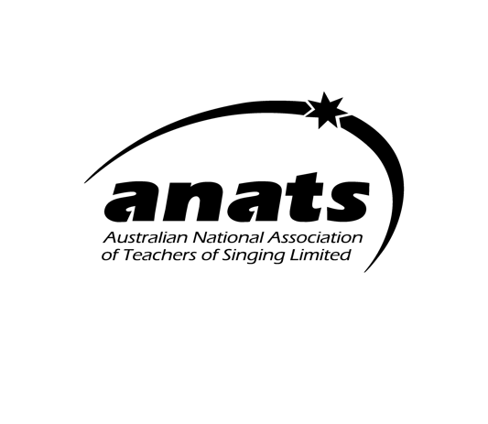
OWLS 2023-24 Scholarship
Older people Who Love Singing (OWLS)
The OWLS scholarship
- Is worth $1000. & made possible through a generous donor
- Is open to all Victorian residents 32 years and older.
- Is now open for applications until 20th February 2024.
- aims to assist a mature-aged singer on their singing journey .
- must be spent on lessons/workshops/courses pertaining to singing (e.g. voice lessons, languages, body-awareness techniques).
- People of all levels of singing experience may apply, but the applicant must not be a professional singer or voice teacher
Application deadline is 20th February 2024. Please email to julianafisi@optusnet.com.au or post to c/o ANATS Victorian Chapter,
- 229 Booran Road, Caulfield South VIC 3162.
- Applications shall consist of:
  - A letter of application detailing why the applicant should be awarded the scholarship (approx. 300 words) along with a simple budget showing how the money would be spent.
  - If appropriate, please indicate whether they are experiencing financial hardship as this will be one of the criteria considered when assessing applications.
  - A link to a video recording of the applicant singing two contrasting songs or song excerpts.
The recording can be of the applicant singing unaccompanied OR using a backing track OR live accompaniment (bearing in mind COVID-19 related considerations).
  - The recording shall be uploaded as a private video on YouTube and the link provided.
  - There is no expectation of a polished performance, but that we simply want to hear you sing and get an overall impression of the applicant.
- Applications will be viewed by a panel of three, comprising two members of the Victorian Chapter committee of ANATS Ltd and one independent industry professional who is not necessarily a member of ANATS Ltd.
- The criteria upon which the selection will be made are:
  - The applicant’s musicality and expressivity evident in his/her performance.
  - The merit of the applicant’s argument in outlining their circumstances, including any hardship.
  - The viability and merit of the study plans outlined by the applicant.
- All applicants will be notified of the outcome within two weeks of the closing date of applications.
- The successful recipient must submit an acquittal detailing how the money has been spent within 12 months of award of the scholarship

